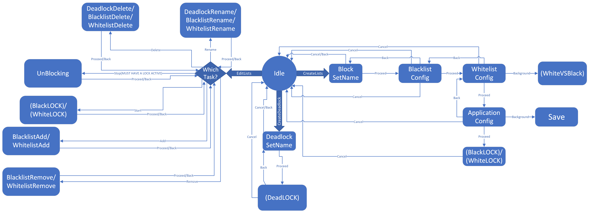

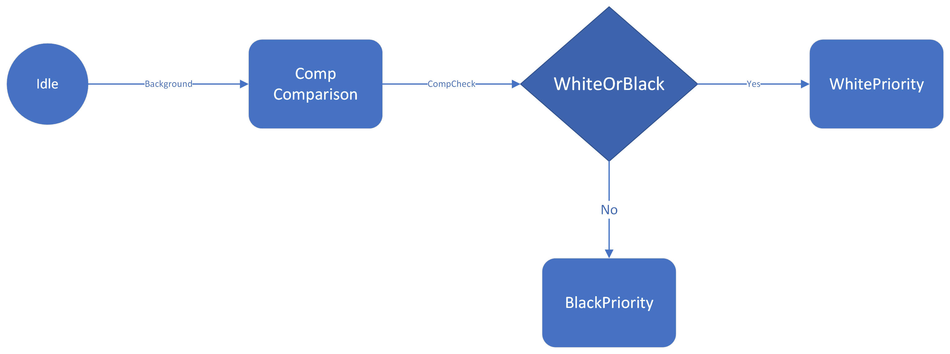

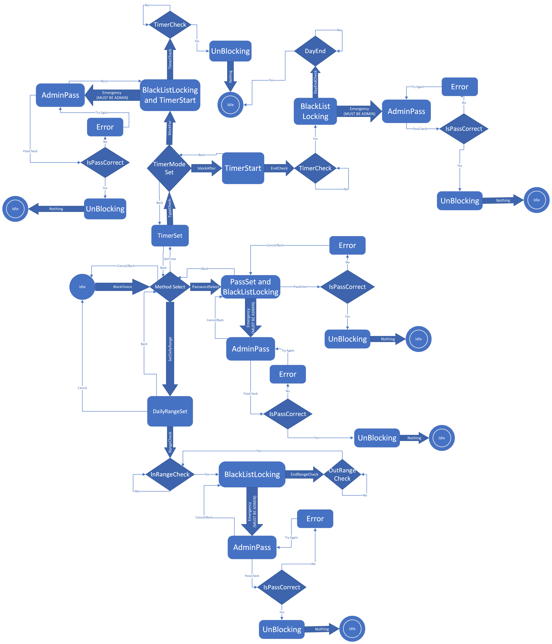

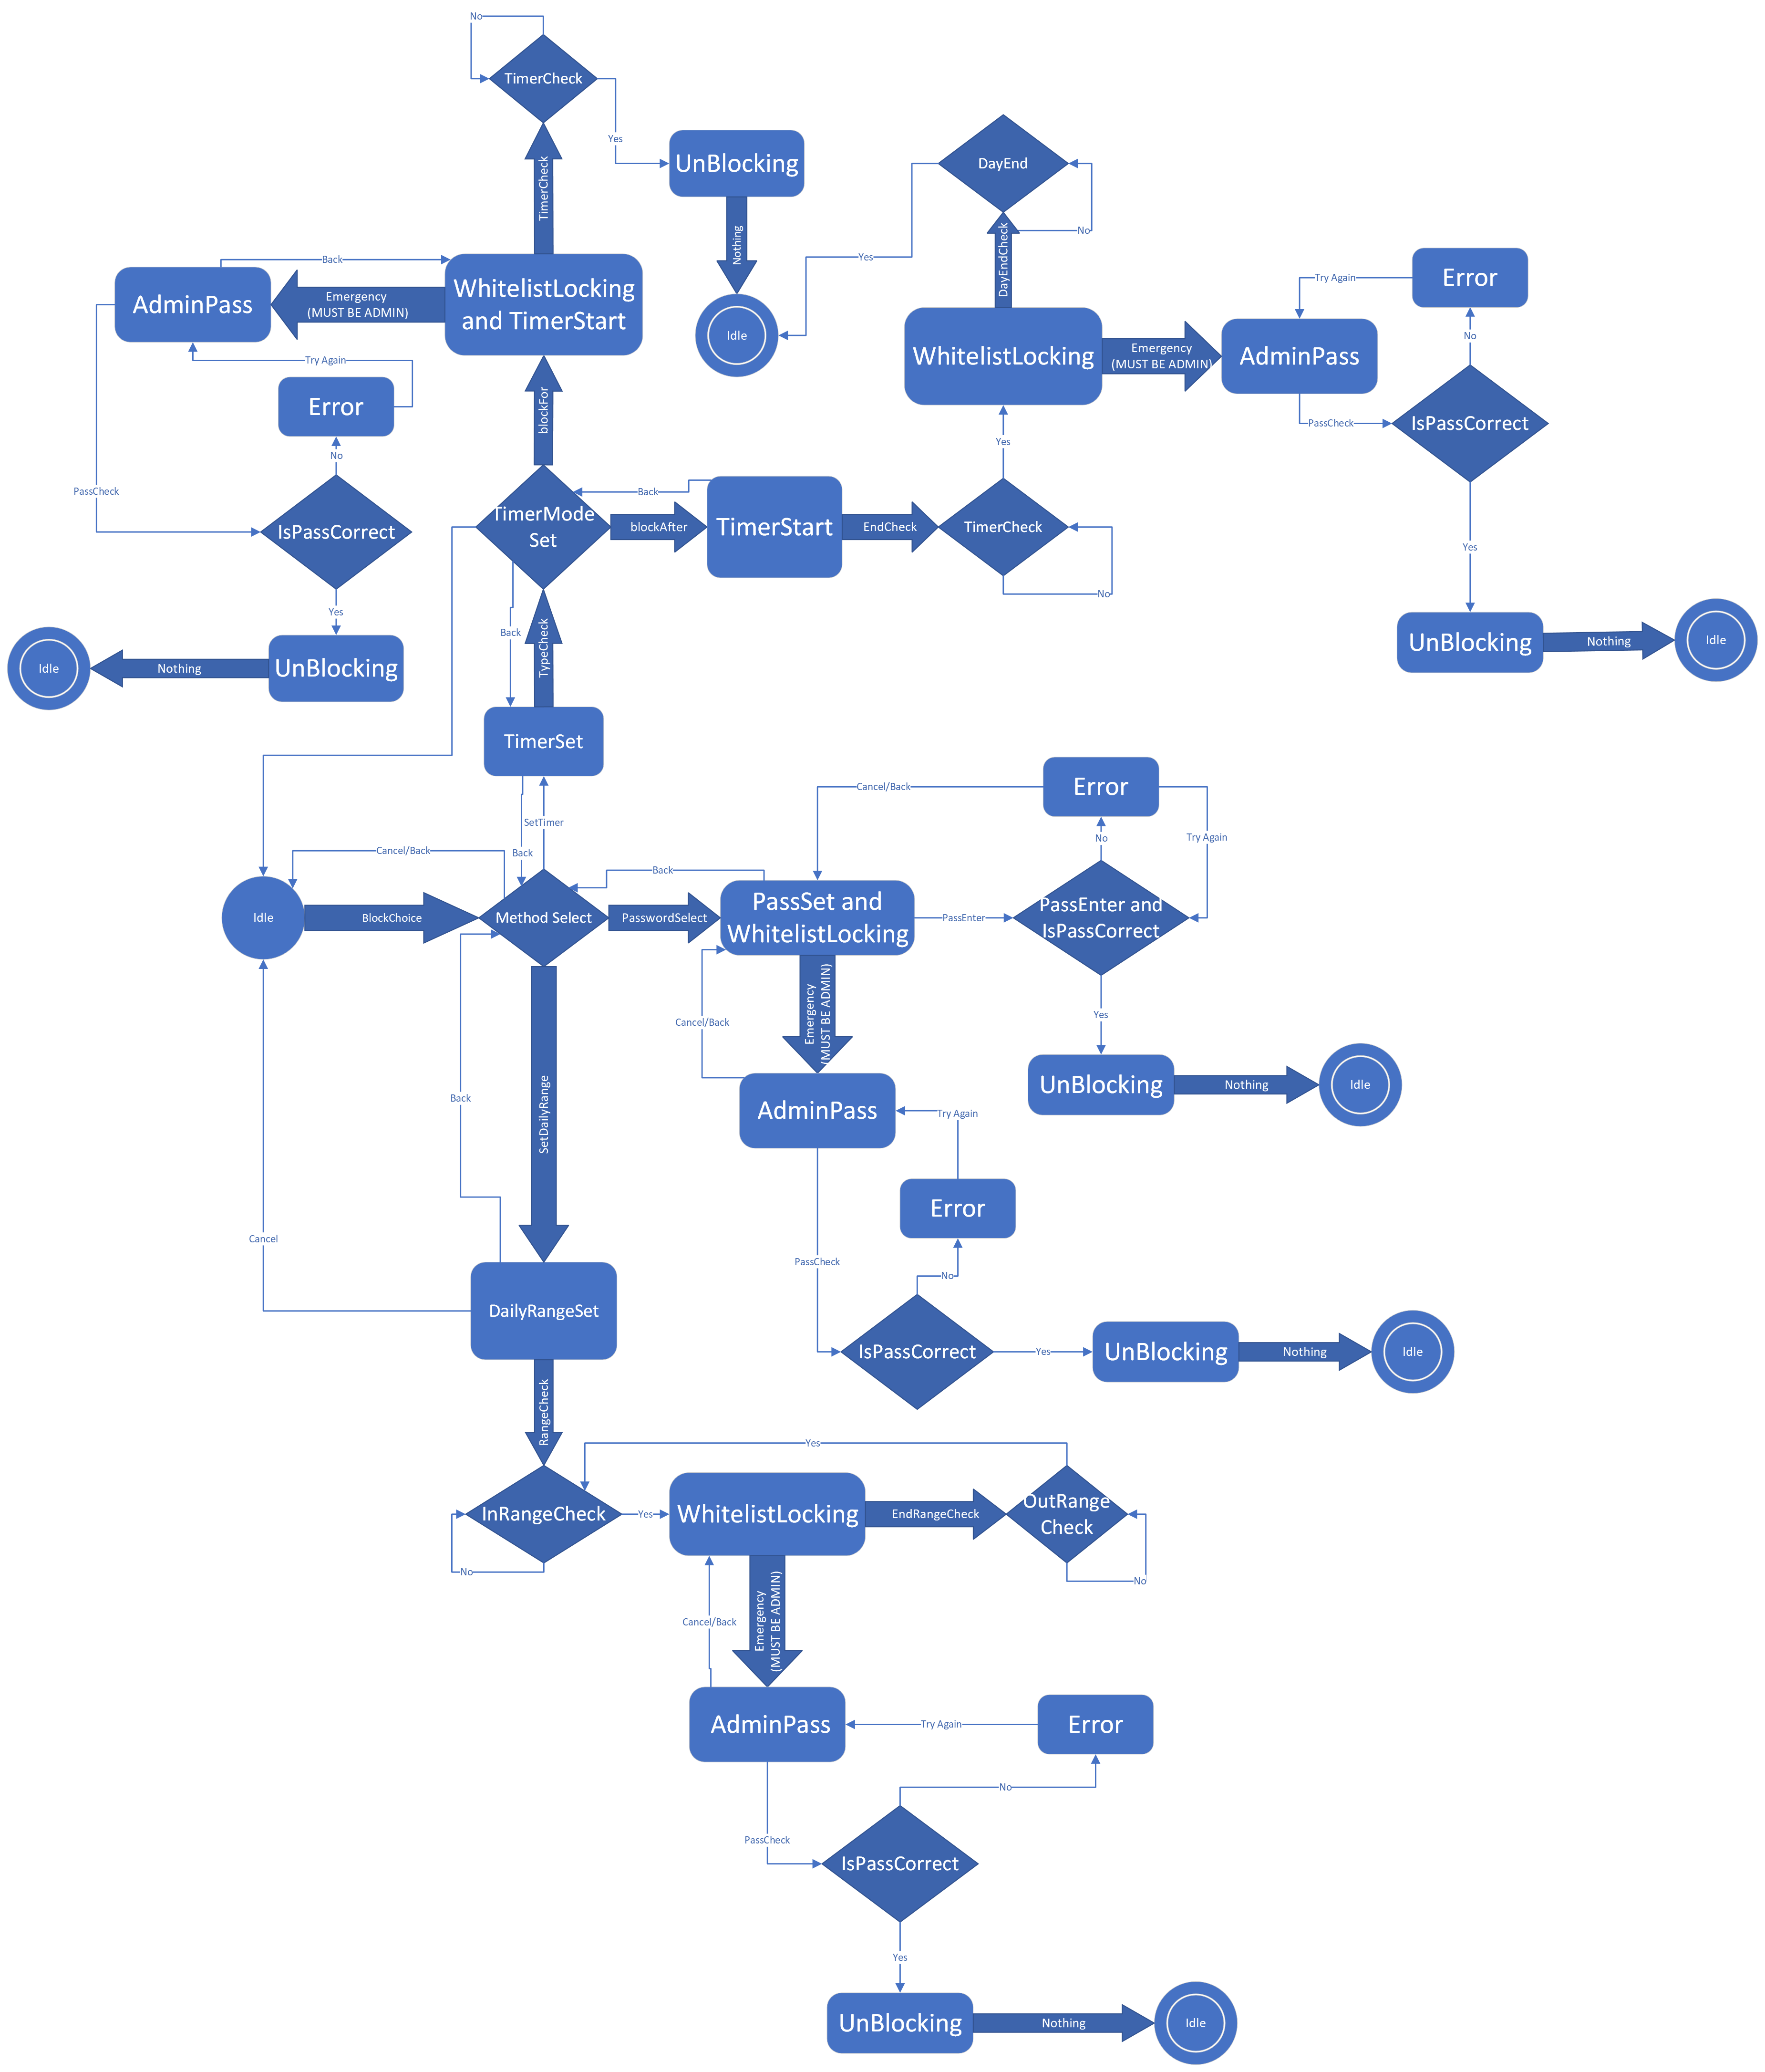
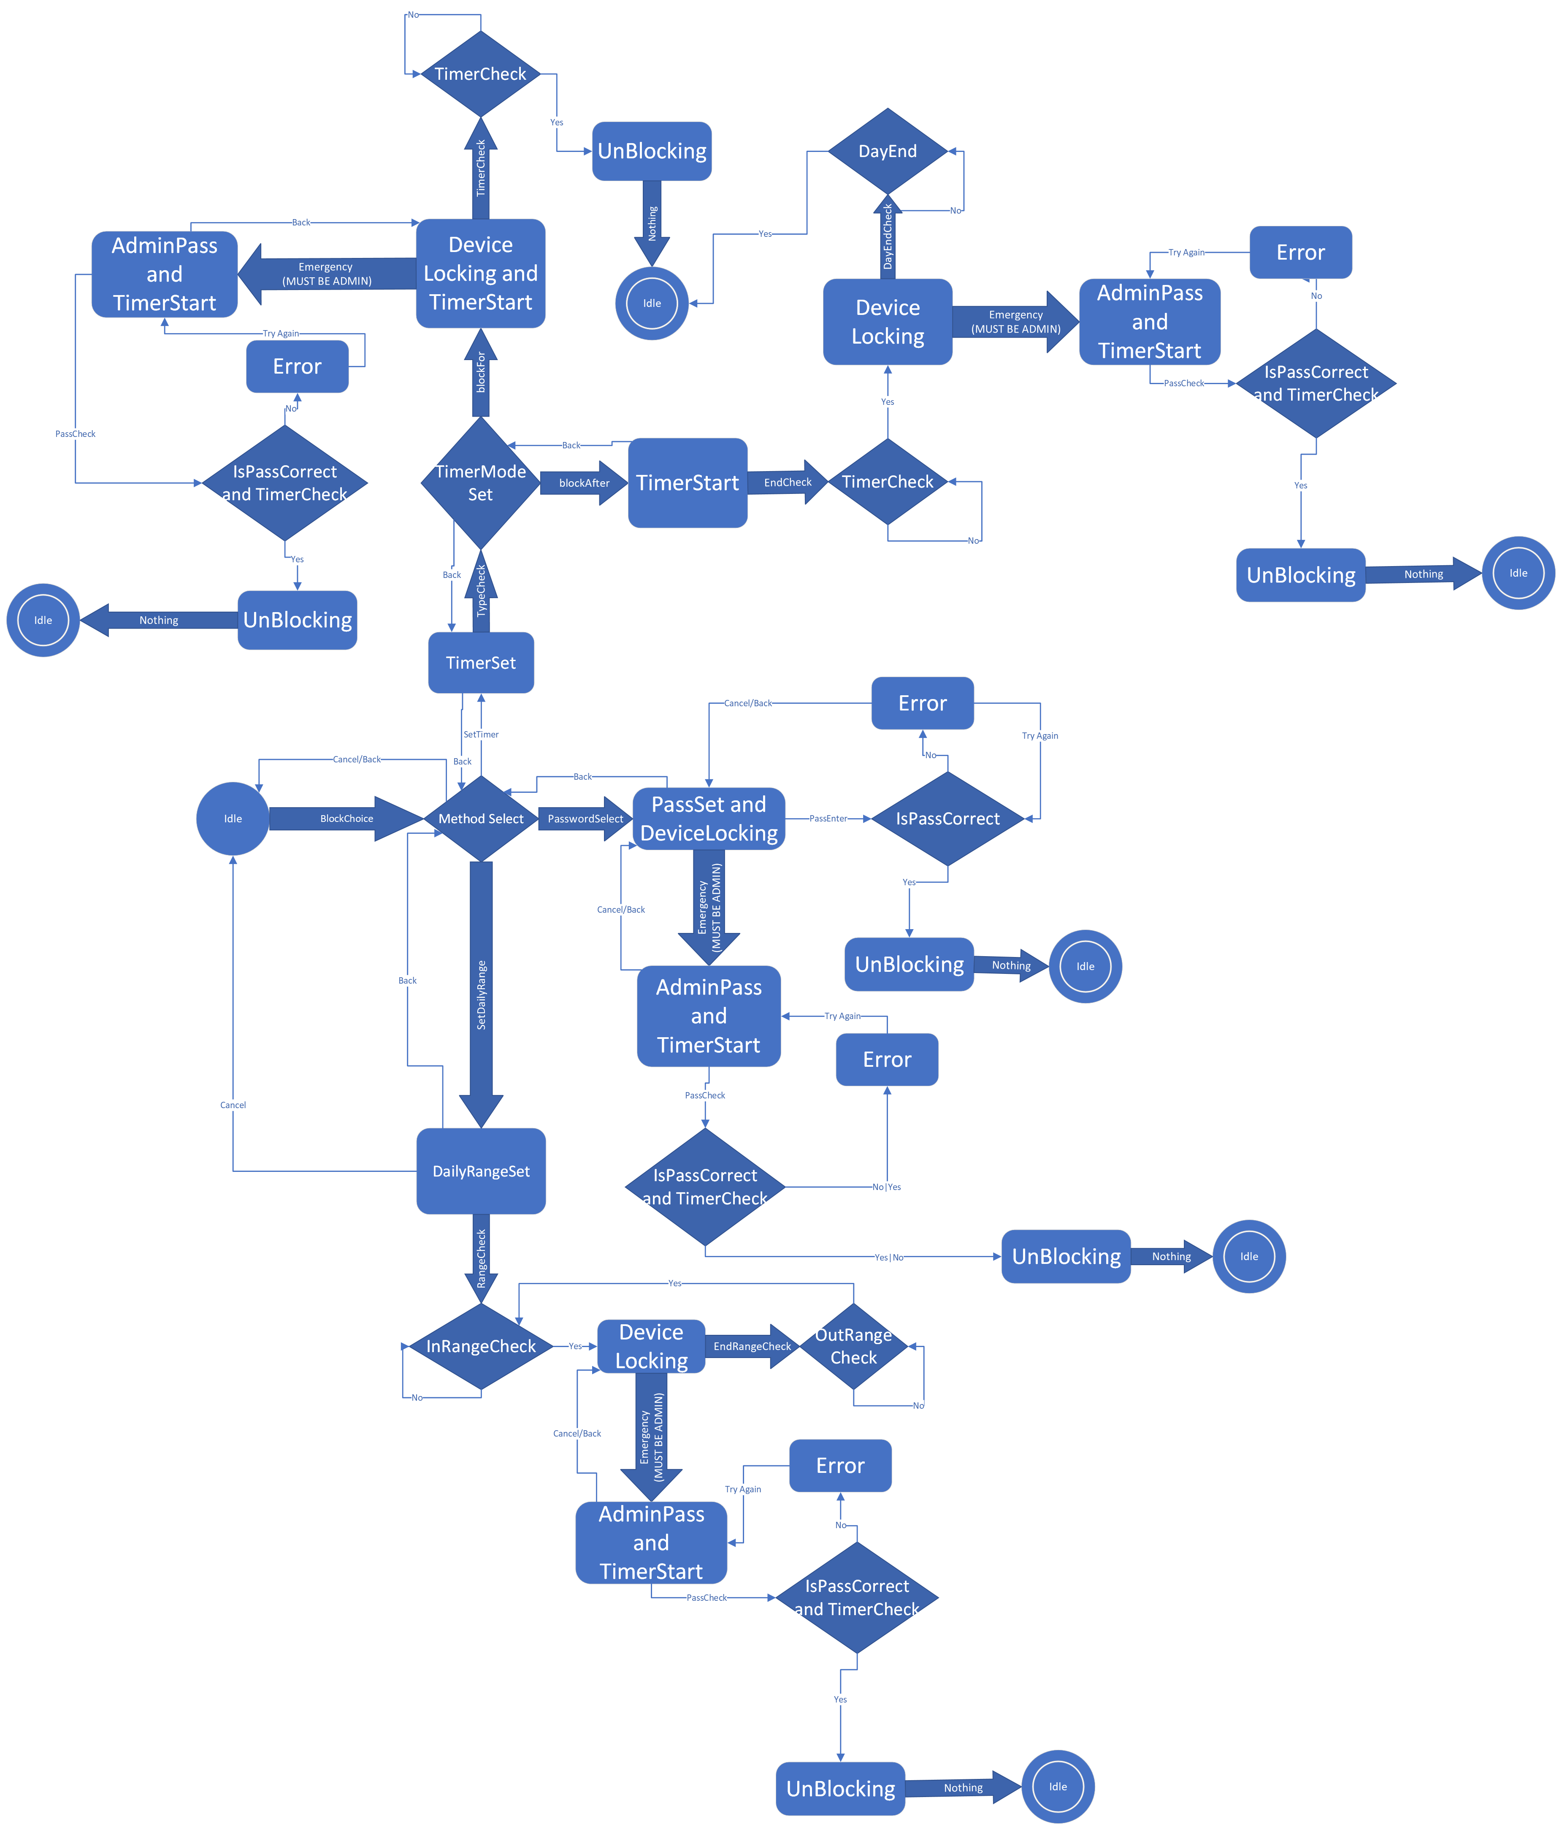

StartMenu
Proceed | User chooses to proceed to the next step by clicking the corresponding button
Back | User chooses to go back to the previous step by clicking the corresponding button
Cancel | User chooses to cancel the current step by clicking the corresponding button
CreateLists | User chooses to start creating the lists (blacklist and whitelist) by clicking the corresponding button
CreateDeadlock | User chooses to start creating a deadlock for the device by clicking the corresponding button
EditLists | User chooses to edit the currently saved lists by clicking the corresponding button
Rename | User chooses to rename one of the saved lists by clicking the corresponding button
Delete | User chooses to delete one of the saved lists by clicking the corresponding button
Stop | User chooses to stop one of the currently active blocks by clicking the corresponding button
Start | User chooses to start the block for one of the saved lists by clicking the corresponding button
Add | User chooses to add a new URL/application to one of the saved lists by clicking the corresponding button
Remove | User chooses to remove an existing URL/application to one of the saved lists by clicking the corresponding button
Locks
Cancel | User chooses to cancel the operation
Back | User chooses to go back by clicking the “back” button
Yes | Previous condition is true
No | Previous condition is false
BlockChoice | User chooses that he/she wants to block the previous set blacklist/whitelist or deadlock
SetDailyRange | User chooses the Daily Range Block Type by clicking the corresponding button
PasswordSelect | User chooses the Password Block Type by clicking the corresponding button
SetTimer | User chooses the Timer Block Type by clicking the corresponding button
TypeCheck | User gets presented to which way he/she want to activate the timer block (Block for a duration of timer, or after the timer ends till the end of the day)
blockFor | User chooses to Block the chosen list/device for a duration of the timer by clicking the corresponding button
blockAfter | User chooses to Block the chosen list/device after the timer ends till the end of the day by clicking the corresponding button
EndCheck | Automatically switches the state to checking the timer ended or not
DayEndCheck | Automatically switches the state to checking if the day has ended or not
PassEnter | User chooses to enter password by clicking the corresponding button, and types it then presses proceed
RangeCheck | Automatically switches the state to constantly checking if time entered the set daily range
EndRangeCheck | Automatically switches the state to constantly checking if time exited the set daily range
Emergency | Emergency cancellation of the block
Nothing | Automatically switches state to idle
WhiteVSBlack
Background | The program does the next state in the background
CompCheck | Automatic action to go check the components of the blacklist and whitelist
Yes | Previous condition is true
No | Previous condition is false

StartMenu
Idle | The program is currently doing nothing
() SetName | Setting the name of the chosen list (can be done for Blacklist/ Deadlock)
() Config | Configuring the list: a field that asks the user to enter the website URLs to put in blacklist/whitelist one at a time. Entering * should block all.
Save | Saving the current block into database
WhichTask | Options presented for user and user picks which task he would like to do
() Rename | Renaming the chosen list (can be done for Blacklist/ Whitelist/ Deadlock)
() Delete | Deleting the chosen list (can be done for Blacklist/ Whitelist/ Deadlock)
UnBlocking | Unblocking the currently active and chosen list
() Add | Adding an extra website/app to the chosen list (can be done for Blacklist/ Whitelist)
() Remove | Remove an existing website/app to the chosen list (can be done for Blacklist/ Whitelist)
Locks
Idle | The program is currently doing nothing
Method Select | User has the choice of all available methods of blocking and user chooses which method he would like to choose
BlackListLocking | Locking all websites/apps in the blacklist
DeviceLocking | Locking all websites/apps (completely locking the device)
WhitelistLocking | Locking all websites/apps that are NOT in the whitelist
TimerSet | Setting a timer
TimerCheck | Is the Timer done?
DayEnd | Did the day end? (24 hour reset)
TimerStart | Timer has started
TimerEnd | Timer has ended
TimerModeSet | Choosing to lock after timer ends, or to block for duration of timer
DailyRangeSet | Setting a range of time of the day (e.g., 8am - 4pm, 10pm - 6am)
InRangeCheck | Is the current time in range
OutRangeCheck | Is the current time out of range
PassSet | Sets the password
IsPassCorrect | Is the password entered correct
Error | Incorrect password entered/Timer is done
UnBlocking | Unblocking the currently active and chosen list
AdminPass | Enter the administrator password
WhiteVSBlack
Idle | The program is currently doing nothing
Comp Comparison | Comparing blacklist with whitelist to find if any website/ application is in both
WhiteOrBlack | If a whitelist URL/application conflicts with a URL/application in the blacklist of the same block, priority is given to the whitelist. If a whitelist URL/application c conflicts with a URL/application in the blacklist of a different block, priority is given to the blacklist
WhitePriority | The URL/application c in the whitelist is more important so the same URL/application c in the blacklist is neglected
BlackPriority | The URL/application in the blacklist is more important so the same URL/application in the whitelist is neglected

